2. Locate one bug or bad workflow within the app.

**Ans:** Since I don’t know the business design, according my knowledge, below are some issues or bad work flow, I found (need not necessarily be bugs.)

**Bugs:**

1. Bug:

On page load, home page have the following url

<https://www.shipt.com/>

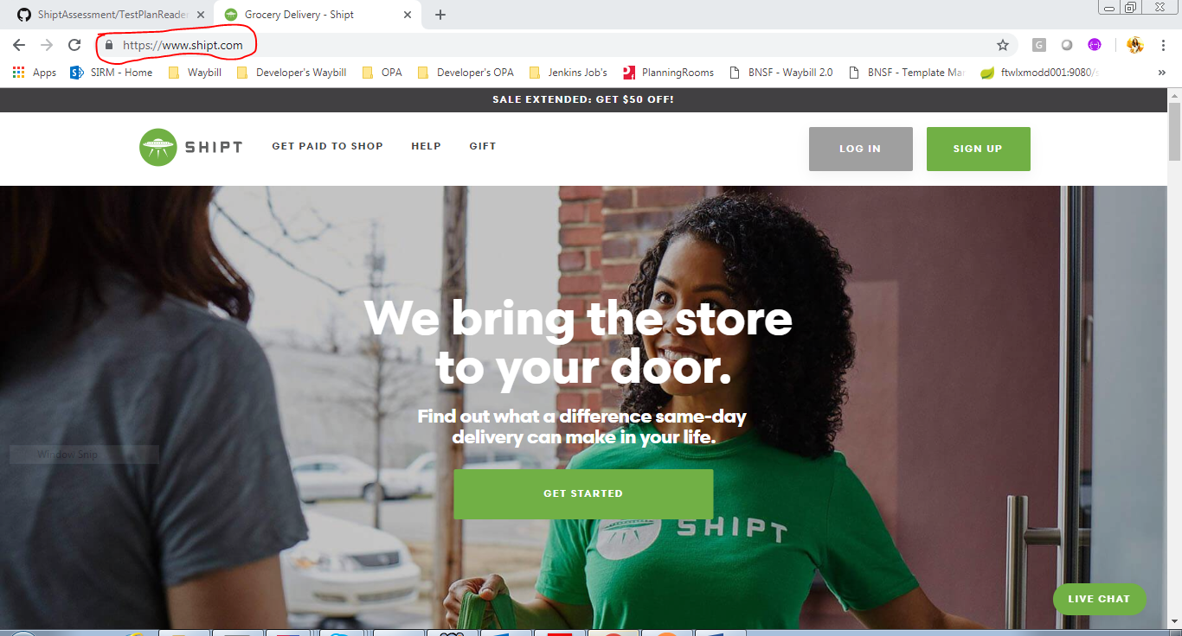

STEPS:

* Click on signup button in home page and you will be navigated to sign up page.
* Now click on Shipt logo. Now you will be navigated back to home page.
* Now home page url (which is below) doesn’t match with the original url, although the pages are same before and after navigation. It is not consistent.

<https://www.shipt.com/?noredirect>

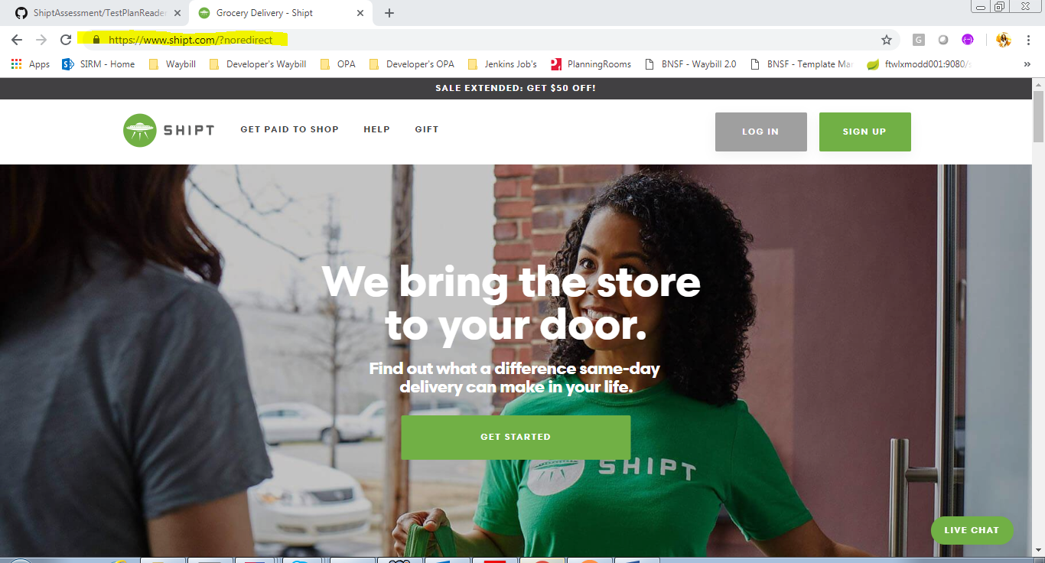

Priority – Low (Because it’s not affecting any business value)

1. Bug: On click of Shipt logo, page is not navigating anywhere (misleading)

STEPS:

* Naviagate to Login page on shipt website which is <https://shop.shipt.com/login>
* Click on shipt logo or on shipt text next to shipt logo, according UX/UI standards it is supposed to take to home page
* (Not sure what is the shipt idea behind having cursor style as on shipt logo as clickable cursor but not navigating anywhere upon click)
* As a user I would expect such feature. That is how most popular website’s work out there on internet.

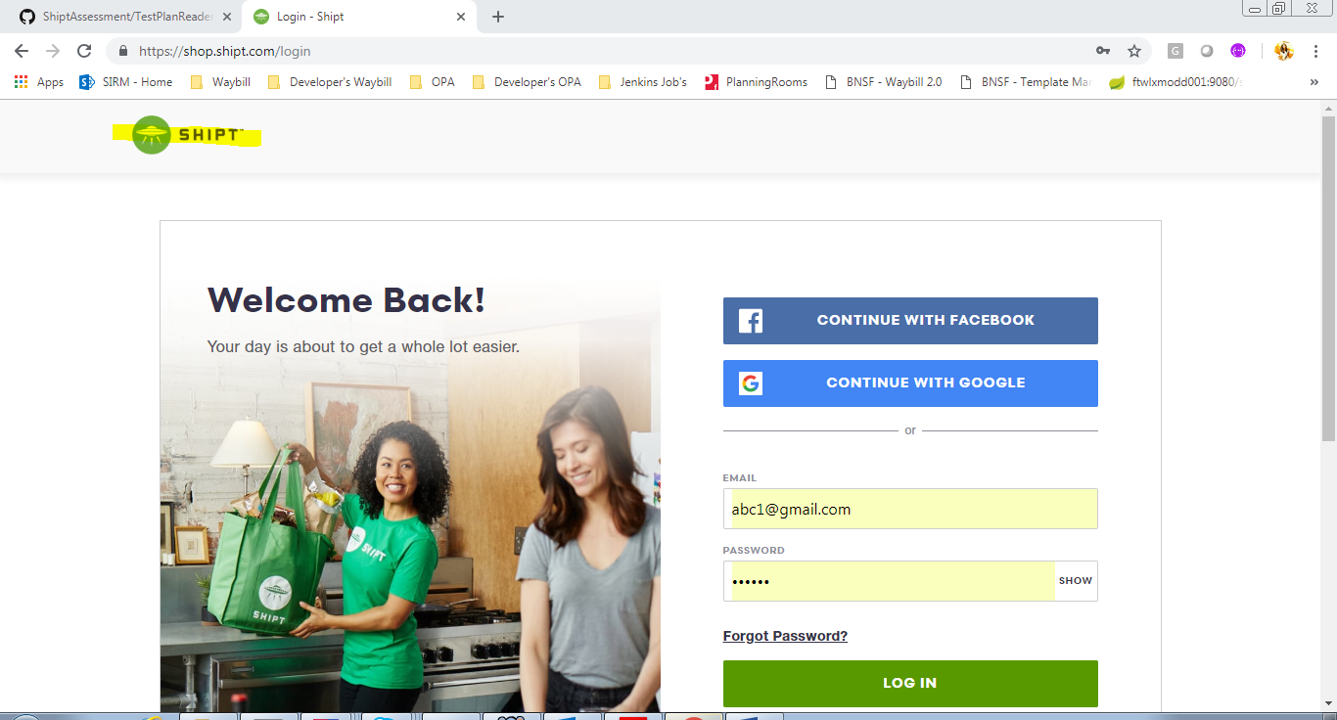

Priority – Low (Because it’s not affecting any business value)

1. Bug:

STEPS:

* On click of ‘Continue with Facebook’ in login page, user is navigated to account homepage.
* Now click on browser back button, sometimes it is throwing json exception upon continuous clicking browser back button.

Priority – Low (intermittent issue)

**Bad User Experience:**

1. **Steps:**

* Navigate to <https://www.shipt.com/be-a-shopper/>
* Click on ‘apply now’ button and press enter or click on ‘start’ button
* A browser level Scroll bar is already present and the apply form have another a scroll bar with so much of white space inside the page.

If I would do it,

* Make the best use of the page layout, redesign the apply form and remove the occurrence scroll bar inside a scroll bar to meet UX/UI standards
* Placeholders in the fields of apply form page, are looking somewhat disabled instead of having user to feel that the field is having focus or is the active element.
* Too much of scrolling from

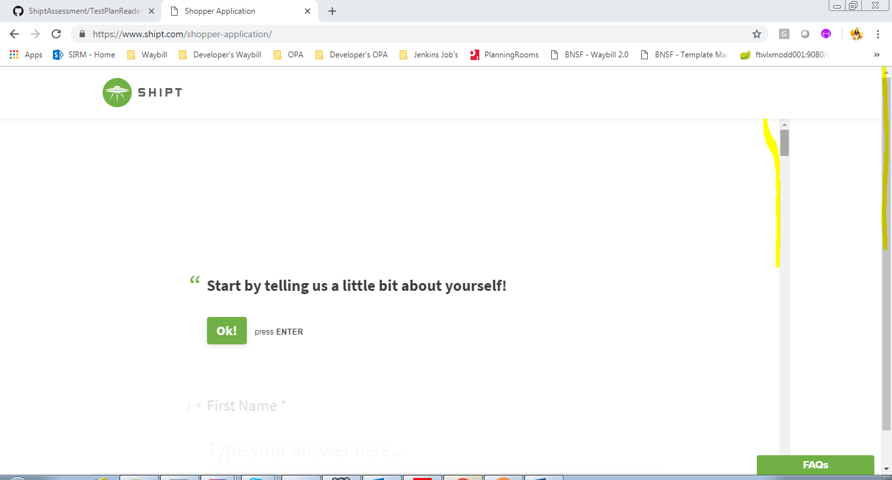

1. **Promotion popup** upon page load is annoying every time, upon home page refresh. (Although it is promotional purpose, it is annoying)



1. Entering promo code before logging in or singing up is not a good idea. Should have that feature inside the account.

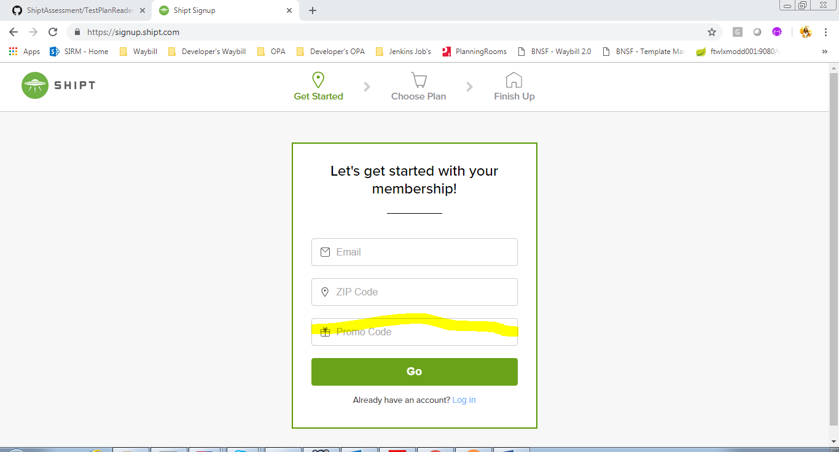

1. Sign up account flow on click of sign up button in home page is different from sign up button click in login page

Both sign up’s have different work flow:

